1 INTRODUCTION

1.1 OVERVIEW
As of my last knowledge update in September 2021, I don't have specific information on a predefined "Tableau HR Scorecard" template or solution. However, I can provide you with general guidance on creating an HR scorecard using Tableau, as Tableau is a powerful data visualization tool that can be customized for various business purposes.
An HR scorecard typically includes key performance indicators (KPIs) and metrics related to human resources, such as employee turnover, recruitment effectiveness, employee engagement, training and development, and other relevant factors. Here's a general process for creating an HR scorecard in Tableau:
As of my last update in September 2021, there isn't a standardized or pre-built "Tableau HR Scorecard" provided by Tableau itself. However, I can provide you with a general overview of what a Tableau HR scorecard might involve and include. Please note that specific details can vary based on the needs of your organization.
- Dashboard Overview:
  - The HR scorecard in Tableau typically starts with a high-level dashboard providing an overview of key HR metrics. This might include summary metrics like total headcount, turnover rates, and overall employee satisfaction.
- Employee Demographics:
  - Breakdowns of employee demographics such as age, gender, and department can be important for assessing diversity and inclusion within the workforce.
- Recruitment Metrics:
  - Metrics related to recruitment effectiveness can be included, such as time-to-fill for positions, source of hires, and the cost per hire.
- Performance Metrics:
  - Metrics related to employee performance, such as average performance ratings, training completion rates, and goal attainment, may be displayed.
- Turnover and Retention:
  - Track turnover rates, reasons for turnover, and retention efforts. This could include voluntary vs. involuntary turnover and trends over time.
- Training and Development:
  - Include metrics related to employee training and development. This might involve tracking the number of training hours per employee, completion rates for training programs, and the impact of training on performance.
- Employee Engagement:
  - Gauge employee engagement through surveys or other metrics. This could include metrics related to employee feedback, satisfaction, and sentiment analysis.
- Compensation and Benefits:
  - Display metrics related to compensation and benefits, such as average salary, benefits enrollment rates, and the cost of benefits per employee.
- Health and Safety:
  - Depending on the nature of your organization, you might include metrics related to employee health and safety. This could involve tracking workplace incidents, safety training completion rates, and compliance with safety regulations.
- Interactive Features:
  - Utilize Tableau's interactive features, such as filters and parameter controls, to allow users to customize their view of the data. This enables drill-downs into specific departments or time periods.
- Trend Analysis:
  - Use trend lines and historical data to analyze patterns and changes over time. This can provide insights into the effectiveness of HR initiatives.
- Geographical Analysis (if applicable):
  - If your organization operates in multiple locations, consider incorporating geographical analysis to visualize HR metrics by region.

1.2 PURPOSE

The purpose of an HR (Human Resources) scorecard is to provide a comprehensive view of the performance and effectiveness of HR functions within an organization. It serves as a strategic tool to measure, analyze, and improve various aspects of human resources management. The HR scorecard typically involves tracking key performance indicators (KPIs) and metrics related to HR activities. Here are some of the primary purposes of an HR scorecard:
- Performance Measurement:
  - Assess and measure the performance of HR initiatives, programs, and processes. This includes evaluating recruitment effectiveness, employee development, retention rates, and other HR-related activities.
- Strategic Alignment:
  - Ensure that HR activities align with the overall strategic goals and objectives of the organization. The scorecard helps in demonstrating the contribution of HR to the achievement of broader business goals.
- Data-Driven Decision Making:
  - Provide HR professionals and organizational leaders with data-driven insights. By analyzing metrics such as turnover rates, employee engagement, and training effectiveness, HR can make informed decisions to enhance workforce management.
- Identifying Areas for Improvement:
  - Highlight areas that need improvement within the HR function. By identifying weaknesses or inefficiencies, organizations can implement targeted interventions to enhance HR processes and practices.
- Employee Development and Engagement:
  - Monitor and evaluate programs related to employee development, training, and engagement. The scorecard helps in assessing the impact of these initiatives on employee satisfaction, performance, and retention.
- Cost Management:
  - Track HR-related costs and analyze their efficiency and effectiveness. This includes evaluating the cost per hire, cost of training programs, and other expenses related to human capital management.
- Risk Management:
  - Identify and mitigate HR-related risks, such as high turnover rates, compliance issues, or gaps in workforce skills. The scorecard can serve as an early warning system for potential HR challenges.
- Communication and Transparency:
  - Enhance communication and transparency by providing a clear and concise overview of HR performance to stakeholders, including executives, managers, and employees.
- Continuous Improvement:
  - Facilitate a culture of continuous improvement within the HR function. Regularly updating and analyzing the scorecard allows HR professionals to adapt and evolve their strategies in response to changing organizational needs.
- Benchmarking:
  - Compare HR metrics against industry benchmarks or best practices. Benchmarking helps organizations understand how their HR performance compares to that of similar organizations and identify areas where they can excel.
- Demonstrating Value:
  - Showcase the value that HR brings to the organization. By quantifying the impact of HR initiatives on key business outcomes, the HR scorecard helps in demonstrating the strategic importance of the HR function.

2 PROBLEM DEFINITION &DESIGN THINKING

2.1 EMPATHYMAP

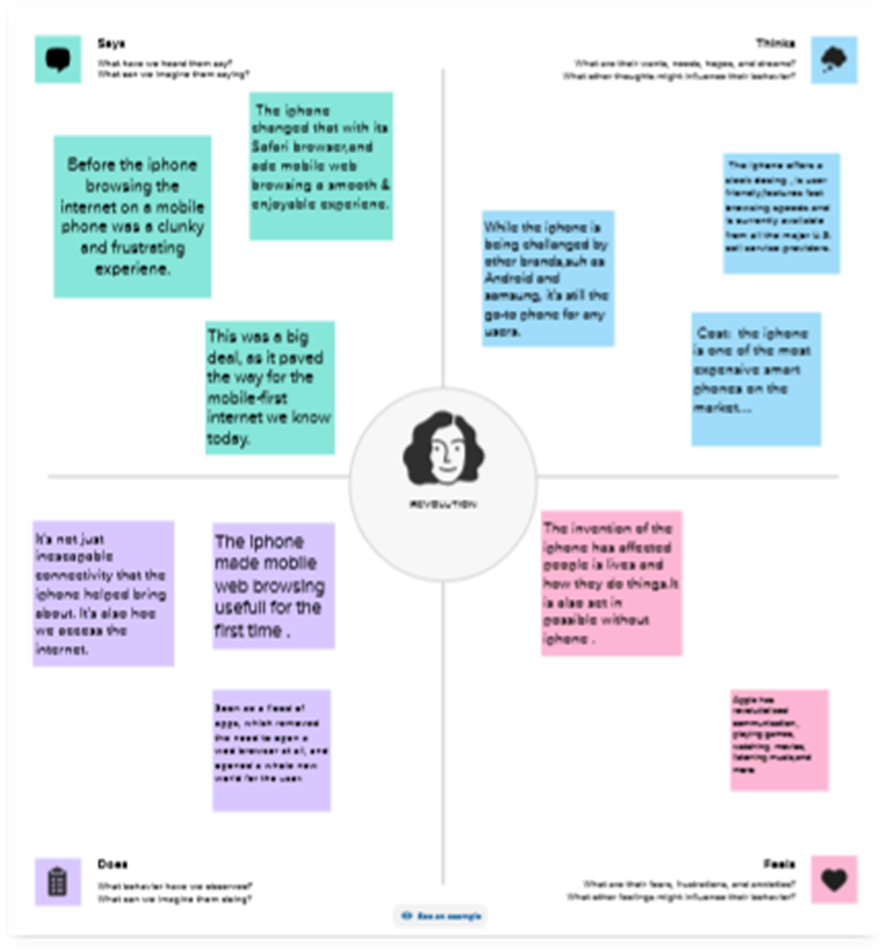

2.2 IDEATION &BRAINSTORMING MAP

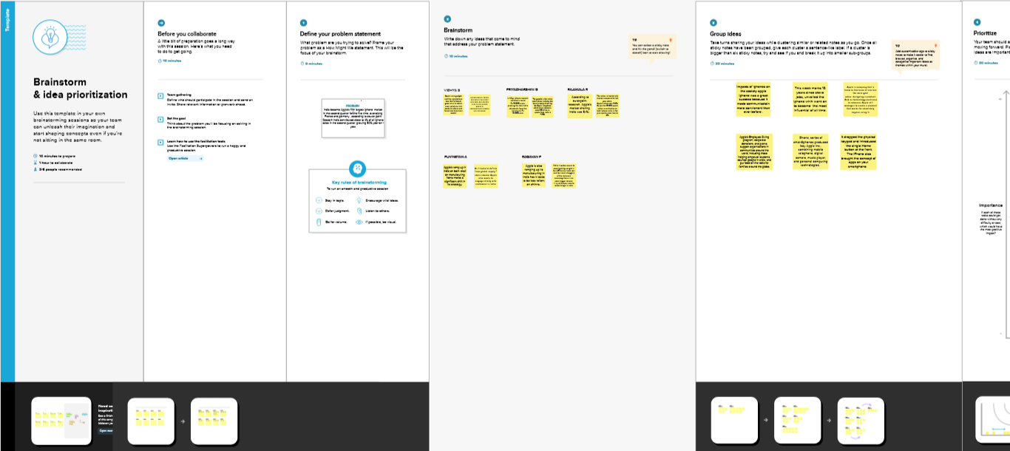

3 RESULT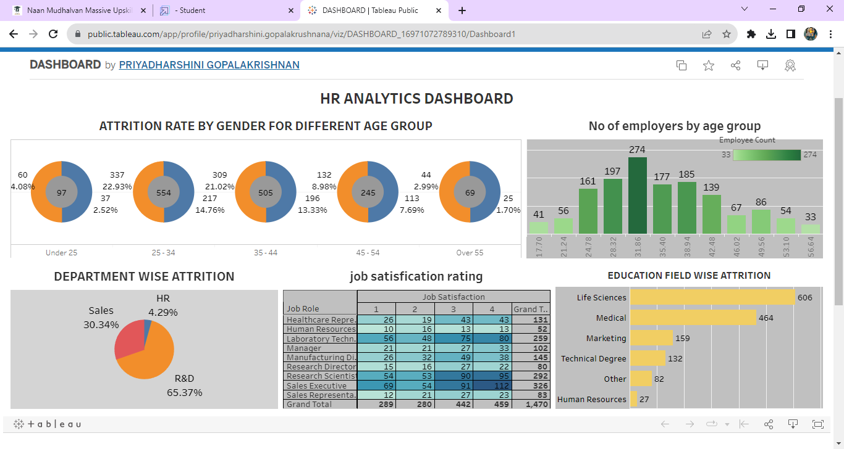
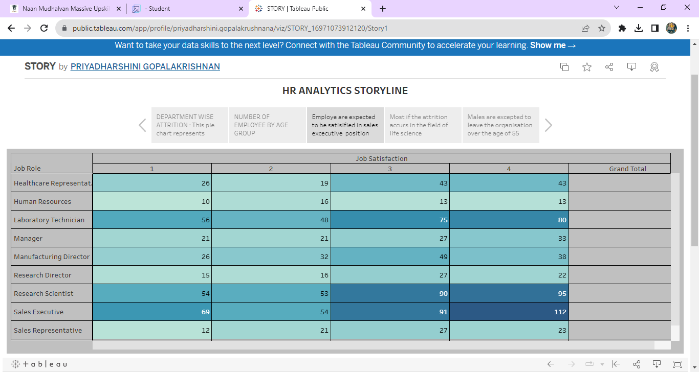

4 ADVANTAGES & DISADVANTAGES

Advantages of Using Tableau for HR Scorecards:
- Data Visualization:
  - Pros: Tableau is renowned for its powerful data visualization capabilities. It allows HR professionals to present complex HR metrics and KPIs in a visually compelling and easy-to-understand format.
- User-Friendly Interface:
  - Pros: Tableau provides an intuitive and user-friendly interface, making it accessible for HR professionals with varying technical expertise. Drag-and-drop features simplify the creation of interactive dashboards.
- Integration with Multiple Data Sources:
  - Pros: Tableau can connect to a wide range of data sources, including databases, spreadsheets, and cloud-based services. This versatility enables HR teams to consolidate data from various systems for comprehensive reporting.
- Real-Time Data Updates:
  - Pros: Tableau supports real-time data updates, allowing HR professionals to access the most current information. This is crucial for making informed decisions based on up-to-date HR metrics.
- Interactivity and Drill-Down Features:
  - Pros: Users can interact with Tableau dashboards by drilling down into specific data points. This interactivity helps HR professionals analyze trends, identify outliers, and gain deeper insights into workforce analytics.
- Scalability:
  - Pros: Tableau is scalable and can handle large datasets. This is beneficial for HR departments dealing with substantial amounts of employee-related data.

Disadvantages of Using Tableau for HR Scorecards:
- Cost:
  - Cons: Tableau can be relatively expensive, especially for larger organizations or for advanced features. Licensing and implementation costs may need to be carefully considered.
- Learning Curve:
  - Cons: While Tableau is user-friendly, there can still be a learning curve for users who are not familiar with data visualization tools. Training may be required to maximize its potential.
- Dependency on IT Support:
  - Cons: Creating complex HR dashboards may require IT support, particularly if integration with multiple data sources or advanced data manipulations are necessary. This could potentially slow down the implementation process.
- Limited Predictive Analytics:
  - Cons: Tableau's primary strength lies in data visualization rather than advanced predictive analytics. Organizations seeking extensive predictive modeling may need to integrate Tableau with other tools.
- Security Considerations:
  - Cons: Handling sensitive HR data requires robust security measures. While Tableau provides security features, it's essential for organizations to configure and manage these settings appropriately.
- Dependency on Data Quality:
  - Cons: The effectiveness of Tableau dashboards depends on the quality of the underlying data. Inaccurate or incomplete data can lead to misleading visualizations and insights.
Before implementing Tableau or any other tool for HR scorecards, it's crucial to conduct a thorough analysis of your organization's specific needs, resources, and technical requirements. Additionally, staying informed about the latest developments in Tableau or other data visualization tools is advisable for making informed decisions.

5 APPLICATIONS

While I don't have specific information on a product called "Tableau HR Scorecard," it's possible you're referring to using Tableau for HR analytics or scorecard applications. If you are using Tableau for HR purposes, here are several potential applications:
- Workforce Analytics:
  - Utilize Tableau to analyze workforce data such as employee demographics, turnover rates, and diversity metrics. Visualizations can help identify trends, patterns, and areas for improvement.
- Recruitment and Talent Acquisition:
  - Create dashboards to monitor recruitment metrics, including time-to-fill, cost-per-hire, and source effectiveness. This can aid in optimizing recruitment strategies and improving the hiring process.
- Employee Engagement:
  - Measure and visualize employee engagement through surveys, feedback, or performance metrics. Tableau can help HR professionals identify factors affecting engagement and implement strategies to enhance workplace satisfaction.
- Performance Management:
  - Use Tableau to visualize performance metrics, including key performance indicators (KPIs), employee appraisals, and goal attainment. This can provide insights into individual and team performance.
- Training and Development:
  - Monitor employee training and development initiatives by creating dashboards that track training completion rates, skill development, and the impact of training programs on performance.
- Compensation Analysis:
  - Analyze and visualize compensation data to ensure fairness and competitiveness. Tableau can help identify salary disparities, market trends, and areas where adjustments may be needed.
- Succession Planning:
  - Develop visualizations to identify high-potential employees and create succession planning strategies. This can help organizations ensure a smooth transition in key roles.
- Absenteeism and Leave Management:
  - Track and visualize data related to employee absenteeism and leave patterns. This can assist HR in identifying trends, managing workforce capacity, and addressing potential issues.
- Diversity and Inclusion:
  - Use Tableau to visualize diversity metrics, track progress in diversity and inclusion initiatives, and identify areas for improvement.
- Compliance Reporting:
  - Generate compliance reports and visualizations to ensure that HR processes align with legal and regulatory requirements.
- Employee Satisfaction Surveys:
  - Analyze results from employee satisfaction surveys and visualize the feedback to identify areas of strength and areas that may require attention.
- Health and Wellness Programs:
  - Monitor the effectiveness of health and wellness programs by creating dashboards that track participation rates, health outcomes, and associated costs.
Tableau's data visualization capabilities can empower HR professionals to make data-driven decisions, communicate insights effectively, and contribute to strategic workforce planning. Customized dashboards can be tailored to the specific needs and priorities of an organization's HR function. It's important to ensure that data privacy and security measures are in place when handling sensitive HR information.

6 CONCLUSION
It appears there might be a slight typo in your question ("CONCLUSION IN THE TABEAU"). I assume you're asking for a summary or conclusion regarding the use of Tableau in HR applications. If that's the case, here's a summary:
In conclusion, leveraging Tableau for HR analytics and scorecard applications offers numerous advantages for organizations. Tableau's robust data visualization capabilities empower HR professionals to transform complex workforce data into meaningful insights. From workforce analytics and talent acquisition to performance management and diversity tracking, Tableau enables the creation of dynamic dashboards that facilitate informed decision-making.
The user-friendly interface of Tableau, coupled with its ability to integrate with various data sources, makes it accessible to HR teams with varying technical expertise. Real-time data updates and interactive features allow for a dynamic exploration of HR metrics, fostering a deeper understanding of trends and patterns.
However, organizations should be mindful of potential challenges, including costs, a learning curve for users, and the need for proper data quality and security measures. Despite these considerations, Tableau remains a powerful tool for HR professionals seeking to enhance their strategic impact by harnessing the power of data visualization.
Ultimately, the effectiveness of Tableau in HR applications depends on aligning its features with the specific needs and goals of the organization. As technology evolves, staying abreast of updates and best practices in Tableau can contribute to optimizing its use for HR functions.

7 FUTURE SCOPE
The future scope of HR scorecards, including tools like Tableau used for HR analytics and reporting, is likely to see several trends and advancements. Here are some potential areas of development in the future:
- Advanced Predictive Analytics:
  - HR scorecards may evolve to incorporate more advanced predictive analytics, helping organizations anticipate workforce trends, identify high-potential employees, and make proactive decisions based on predictive insights.
- AI and Machine Learning Integration:
  - The integration of artificial intelligence (AI) and machine learning (ML) technologies could enhance HR scorecards by automating data analysis, providing deeper insights, and even predicting employee behavior and performance.
- Employee Experience Analytics:
  - Future HR scorecards may focus more on employee experience analytics, capturing data related to employee well-being, sentiment analysis, and overall satisfaction. This could involve the integration of employee feedback from various sources, including surveys and social collaboration platforms.
- Dynamic Real-Time Dashboards:
  - Real-time data updates and dynamic dashboards will likely become even more integral. HR professionals may have access to continuously updated insights, allowing for immediate responses to changes in workforce dynamics.
- Remote Work Analytics:
  - As remote and hybrid work models become more prevalent, HR scorecards may adapt to include analytics related to remote work effectiveness, employee engagement in virtual environments, and the impact of flexible work arrangements on productivity.
- Diversity, Equity, and Inclusion Metrics:
  - The future of HR scorecards may involve more sophisticated metrics related to diversity, equity, and inclusion (DEI). Tools might provide in-depth insights into the effectiveness of DEI initiatives and help organizations address gaps in representation and inclusion.
- Skill and Talent Gap Analysis:
  - HR scorecards may play a crucial role in analyzing skills and talent gaps within the organization. This includes identifying areas where upskilling or reskilling is necessary to meet evolving business needs.
- Blockchain for HR Data Security:
  - The use of blockchain technology for HR data security and privacy could become more prominent. Blockchain may be utilized to enhance the security and integrity of employee data, ensuring that sensitive information is tamper-proof and transparent.
- Integration with HR Chatbots:
  - HR scorecards might integrate with HR chatbots and virtual assistants to provide a more interactive and conversational experience for HR professionals. This could facilitate quicker access to data and insights through natural language queries.
- Continuous Learning and Adaptability:
  - HR scorecards will likely need to adapt to the evolving landscape of HR practices, regulations, and technologies. Continuous learning and adaptability will be key for HR professionals to maximize the value of these tools.
As technology continues to advance, the future of HR scorecards will be shaped by the need for more sophisticated, data-driven HR strategies. Organizations that embrace these trends are likely to gain a competitive advantage in attracting, developing, and retaining top talent.

8 APPENDIX

https://github.com/NM2023TMID11204/iREVOLUTION_NM2023TMID21885

